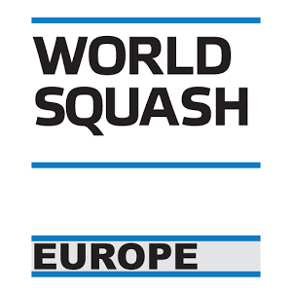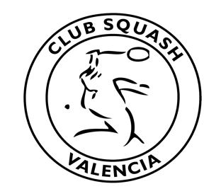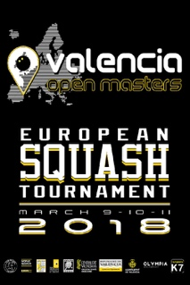

ESF Masters Circuit 2017 – 2018

Spanish Masters 2018 (MO)

Tournament Director
Alejandro Garbí
Phone: +34 606903798
Mail: tutempok7squash@gmail.com

Tournament referee
Chimo Marmaneu

Date
The event will be held in Valencia, Spain from 9 – 11 March 2018. The tournament will start on Friday 9 March at 10:00 and end at Sunday 11 March around 15:00.

Closing date for entries: Thursday, 22 February 2018.
Late entries are only acceptable before the seeding is published at the discretion of the Tournament Director and Masters Sub-Committee in the interest of the tournament.

Venues
TUTEMPO K7 (4 courts)
Pista de Ademuz, Salida 7
46980 Paterna, Valencia
https://goo.gl/maps/wosVeisLbAk

OLYMPIA SPA, AND FITNESS (4 courts)
Camino Maestro Serrano Párale, 1
46120 Alboraya, Valencia
https://goo.gl/maps/MYRjwcC4pfG2

Categories
Men’s: +35, +40, +45, +50, +55, +60, +65, +70, +75
Women’s: +35, +40, +45, +50, +55, +60, +65, +70, +75
The TD reserves the right to combine age groups if there are insufficient entries to make a workable draw: Players are only allowed to enter one category.

Eligibility
This event is open to all players who are over 35, 40, 45, 50, 55, 60, 65 and 70 on the first day of the event. As specified by WSF and ESF, players must hold an active Squash Player Identification Number (SPIN) to compete in all ESF Registered events. Players without a SPIN can register through the WSF website www.worldsquash.org/spin

Seeding
The seeding will be carried out by the Masters Sub-Committee Seeding Panel using the latest available results and ESF Masters Rankings valid at the closing date and in accordance with the ESF Masters Circuit Guidelines.

Matches
All matches played will consist of the best of five games, under the rules of the WSF. All players are guaranteed a minimum of three scheduled matches. PAR 11 scoring (to 2 clear points) will be used.

Draws
Maximum draw size: 64 (3 day event).

Refereeing
All players will be expected to mark and referee matches.

Ball
Dunlop pro xx.

Prizes
Trophies for 1st, 2nd and 3rd place in each age group. Prize giving ceremony 15:00 Sunday.

Insurance
Players enter and play in the tournament at their own risk. Neither the organizers nor the ESF will accept responsibility for any claims including for injury or accident. Suitable insurance must be organized by the player or the participating federation.

Official Hotel
(Reservations can only be made by the tournament organization)
Olympia Hotel Events & Spa ****
Camino Maestro Serrano 3
46120 Alboraya, Valencia
Web: http://www.olympiahotelvalencia.com/
To see pictures of the hotel, follow this link: https://goo.gl/maps/1ccUmvL8Qe22

Transport
Except basic entry fee, all packages include shuttle bus between venues and pick-up /drop-off transport between the airport, Sorolla Train Station and the official hotel.

Furthermore, there is easy underground transport between the airport, Sorolla Train Station and the official hotel.

Entries
All entries must be made on the official entry form and sent to: valenciamasters@clubsquashvalencia.com
The European Masters Circuit is open to all Masters of any nationality provided the player is not banned by MNA.

Payment
The entry fee and package fee, as detailed below, along with the ranking levy of 4€ per player must be paid to the host by the closing date.

Bank details
Bank: SABADELLCAM
Account holder: Club Squash Valencia
IBAN: ES48 0081 1507 73 0001001802

Please mark payment clearly with name of event and name of player:
“SMO2018 / name of player”

Draws
The seeding lists and time of the first matches for specific age groups will be published 5 days prior to the start date.

Finalized draws for the event will only be posted at the venue and on the internet at the start of the event.

ESF regulations & penalties
A late withdrawal is a withdrawal made 2 days or less before the start date of a tournament.

Ranking penalties will be applied to the records of players who fail to turn up or who make a late withdrawal not supported by a medical certificate (see E4a, E4b and F2I)

Following a withdrawal, fees should be reimbursed as follows:
- Withdrawal up to 14 days before the start date of a tournament: fees reimbursed in full (less bank charges)
- Withdrawal 3-14 days before the start date of a tournament: 50% of fees reimbursed (less bank charges)
- Withdrawal 2 days or less before the start date of a tournament: reimbursement at the discretion of the tournament organizer.

If a player:
- Has entered a tournament and fails to turn up, he/she will receive zero ranking points for the tournament
- Fails to play out all scheduled matches for any reason other than illness or injury, he/she will receive zero ranking points for the tournament
- Commits either of these offences for a second time within a 12-month period, he/she will be banned from the ESF Masters Circuit for a period of 12 months.

Information Packages / Entry Fee

A | Basic entry Fee  Entry fee + ESF levy + Welcome pack | € 55 per person
B | Entry fee+ ESF levy + Welcome pack + 2 nights bed and breakfast + Transport Airport or Station-Hotel-Airport or Station + Shuttle Bus Venues | € 225 per person
B-1 | Accompanying person- parents, coaches..)  2 nights bed and breakfast + Transport Airport or Station-Hotel-Airport or Station + Shuttle Bus Venues | € 170 per person
C | Entry Fee + ESF levy + Welcome pack + 3 nights bed and breakfast + Transport Airport or Station-Hotel-Airport or Station + Shuttle Bus Venues | € 295 per person
C-1 | Accompanying persons - parents, coaches …  3 nights bed and breakfast + Transport Airport or Station-Hotel-Airport or Station + Shuttle Bus Venues | € 240 per person
D | Standard package (2 nights)  Entry fee+ ESF levy + Welcome pack + 2 nights bed and breakfast + Transport Airport or Station-Hotel-Airport or Station + Shuttle Bus Venues + 5 meals (Saturday Players Dinner included) | € 330 per person
D-1 | Accompanying person- parents, coaches.  2 nights bed and breakfast + Transport Airport or Station-Hotel-Airport or Station + Shuttle Bus Venues + 5 meals (Saturday Players Dinner included) | € 275 per person
E | Entry Fee +ESF levy + Welcome pack + 3 nights bed and breakfast + Transport Airport or Station-Hotel-Airport or Station + Shuttle Bus Venues 5 meals (Saturday Players Dinner included) | € 380 per person
E-1 | Accompanying persons - parents, coaches…  3 nights bed and breakfast + Transport Airport or Station-Hotel-Airport or Station + Shuttle Bus Venues 5 meals (Saturday Players Dinner included) | € 325 per person

- All packages Extra charge for single room / € 25 per person per night

- Extra night double room / € 70 per person per night
Bed and breakfast, accommodation in double room

- Extra night single room / € 80 per person per night
Bed and breakfast, accommodation in single room

- Saturday Players Dinner / € 25 per person

